**NAVPAD**

**Company profile**

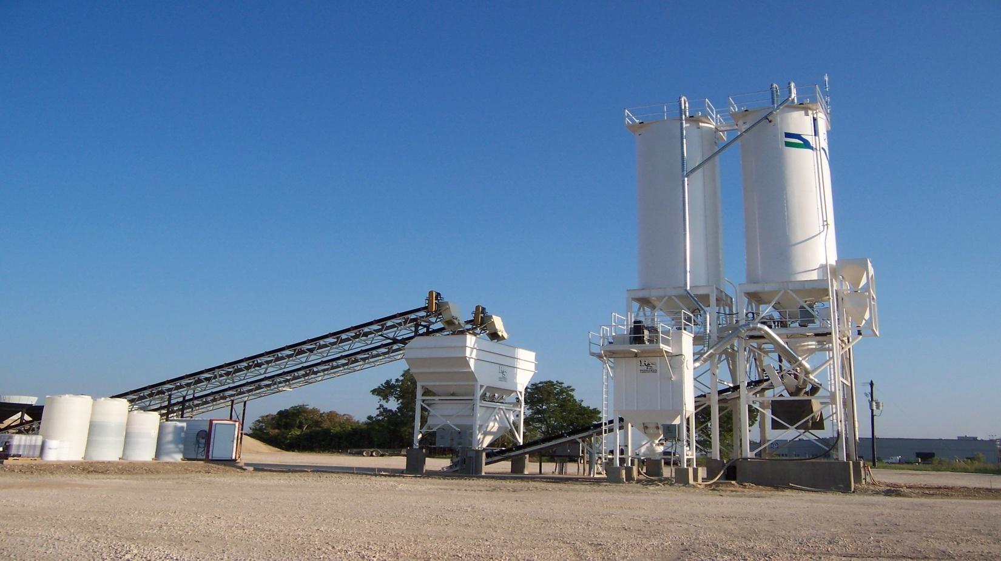

Established in 2009, Next tech Group of Companies a registered company, is one of the prominent and pioneering agencies in India. Its main objective is to deliver high quality, efficient services to our valued clients. We are extremely delighted to say a few words about the activities of Next tech Group of Companies which has reached today noble heights of performance with high level of Clients, in dealing with various services. We must thank all customers of Next tech Group of Companies for their faith and confidence in us, all our principals for their support and everyone associated with us by some way or the other in making this group a success.

In our organization, quality and excellence are not just corporate slogans to garner business and profits; they are a quintessential part of our very being because without high standards, we don't measure up to our own ideals.Our diligent and inspired research gives us an edge over our competitors and puts us at the forefront of our field.

**OUR STRENGTH**

Our team members are the biggest asset of our organization. Their experience and knowledge has been our strengths that has given us an edge over the other service provider in the industry. Our management team and team members utilize their commercial awareness & intellectual enrichment to serve various industries.

**Distibutation facility:-**

* Gandhinagar
* Wanakbori

* Bharuch
* Ukai
* Dahej

**\**

**Introduction**

**Fly ash:-**

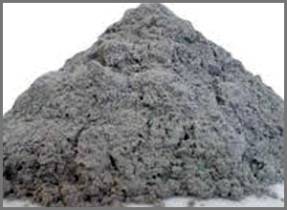

We introduce ourselves as a one of the leading **fly ash** supplier in Gujarat and supply quality fly ash in different packing to different user according to their needs. Our product are cost effecting, create more strength, used as a filler and environment friendly. We regularly doing third party testing of samples (fineness) to achieve the specification required by ISI.

**Special Features**

* Cost effectiveness
* work as a lubricant
* Reduce shrinkage
* Heat resistance
* Environment friendly
* Higher compressive strength over time
* Enhancement in the workability of Portland cement concrete when coal fly ash are added

**Applications**

* For the entire user like Brick plant Manufacturer
* R.M.C (Ready mix concrete plant)
* Builders for slabs and concreting

**Availability**  
Fly ash in Bulker

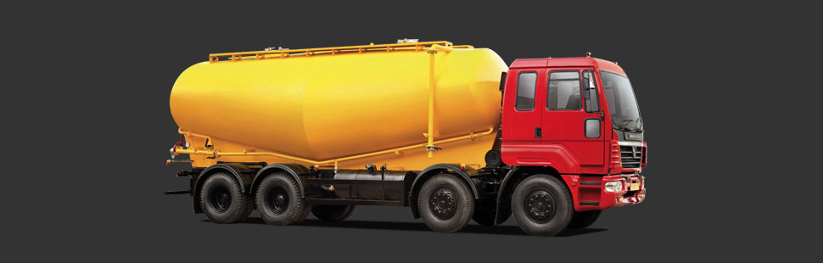

The reuse of fly ash as an engineering material primarily due to its pozzolanic nature, spherical shape, and relative uniformity. Fly ash recycling, in descending frequency, includes usage in :

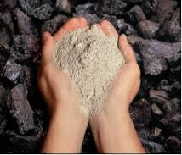

* Portland cement and grout
* As a structural fill
* Waste stabilization
* Raw feed for cement clinkers
* Mine reclamation
* Stabilization of soft soils
* Road sub base
* Aggregate
* Flowable fill

**Chemical Composition**

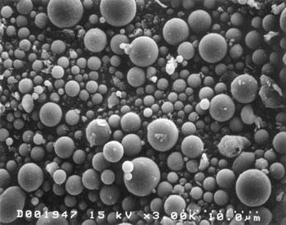

Fly ash material solidifies while suspended in the exhaust gases and is collected by [electrostatic precipitators](https://en.wikipedia.org/wiki/Electrostatic_precipitator) or filter bags. Since the particles solidify rapidly while suspended in the exhaust gases, fly ash particles are generally [spherical](https://en.wikipedia.org/wiki/Sphere) in shape and range in size from 0.5 [µm](https://en.wikipedia.org/wiki/%CE%9Cm) to 300 µm. The major consequence of the rapid cooling is that few minerals have time to crystallize, and that mainly amorphous, quenched glass remains. Nevertheless, some [refractory](https://en.wikipedia.org/wiki/Refractory) phases in the pulverized coal do not melt (entirely), and remain crystalline. In consequence, fly ash is a heterogeneous material. SiO2, Al2O3, Fe2O3 and occasionally CaO are the main chemical components present in fly ashes. The mineralogy of fly ashes is very diverse. The main phases encountered are a glass phase, together with [quartz](https://en.wikipedia.org/wiki/Quartz), [mullite](https://en.wikipedia.org/wiki/Mullite) and the iron oxides [hematite](https://en.wikipedia.org/wiki/Hematite), [magnetite](https://en.wikipedia.org/wiki/Magnetite) and/or [maghemite](https://en.wikipedia.org/wiki/Maghemite). Other phases often identified are [cristobalite](https://en.wikipedia.org/wiki/Cristobalite), [anhydrite](https://en.wikipedia.org/wiki/Anhydrite),[freelime](https://en.wikipedia.org/wiki/Calcium_oxide), [periclase](https://en.wikipedia.org/wiki/Periclase), [calcite](https://en.wikipedia.org/wiki/Calcite), [sylvite](https://en.wikipedia.org/wiki/Sylvite), [halite](https://en.wikipedia.org/wiki/Halite), [portlandite](https://en.wikipedia.org/wiki/Calcium_hydroxide), [rutile](https://en.wikipedia.org/wiki/Rutile) and [anatase](https://en.wikipedia.org/wiki/Anatase). The Ca-bearing minerals [anorthite](https://en.wikipedia.org/wiki/Anorthite), [gehlenite](https://en.wikipedia.org/wiki/Gehlenite), [akermanite](https://en.wikipedia.org/wiki/Akermanite) and various calcium silicates and calcium aluminates identical to those found in [Portland cement](https://en.wikipedia.org/wiki/Portland_cement) can be identified in Ca-rich fly ashes.[[5]](https://en.wikipedia.org/wiki/Fly_ash#cite_note-5) The [mercury](https://en.wikipedia.org/wiki/Mercury_(element)) content can reach 1 [ppm](https://en.wikipedia.org/wiki/Parts-per_notation)[[6]](https://en.wikipedia.org/wiki/Fly_ash#cite_note-6) , but is generally included in the range 0.01 - 1 ppm for bituminous coal. The concentrations of other trace elements vary as well according to the kind of coal combusted to form it. In fact, in the case of bituminous coal, with the notable exception of boron, trace element concentrations are generally similar to trace element concentrations in unpolluted soils.

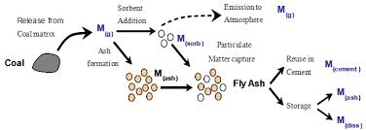

**Chart**

|  |  |  |  |
| --- | --- | --- | --- |
| **Component** | [**Bituminous**](https://en.wikipedia.org/wiki/Bituminous_coal) | [**Sub bituminous**](https://en.wikipedia.org/wiki/Subbituminous) | [**Lignite**](https://en.wikipedia.org/wiki/Lignite) |
| [**SiO2**](https://en.wikipedia.org/wiki/Silicon_dioxide)**(%)** | 20-60 | 40-60 | 15-45 |
| [**Al2O3**](https://en.wikipedia.org/wiki/Aluminum_oxide)**(%)** | 5-35 | 20-30 | 20-25 |
| [**Fe2O3**](https://en.wikipedia.org/wiki/Iron_oxide)**(%)** | 10-40 | 4-10 | 4-15 |
| [**CaO**](https://en.wikipedia.org/wiki/Calcium_oxide)**(%)** | 1-12 | 5-30 | 15-40 |
| [**LOI**](https://en.wikipedia.org/wiki/Loss_on_ignition)**(%)** | 0-15 | 0-3 | 0-5 |

**Properties of fly ash**

**Spherical Particle Shape:**

The spherical shape of Fly Ash particles improves workability when blended with cement particles which are angular in shape. This in turn improves compaction and helps achieve greater densities with the Ash concrete

**Small Average Particle Size:**

The fine Fly Ash particles displace water between the cement particles and act as hydraulic sites for the cement. This not only stimulates the early strength development but

Also improves pore structure. This physical reaction is called the “Fine

Filler Effect”.

**Pozzolanic Reaction:**

Fly Ash forms stable cementitious compounds in reaction with Calcium Hydroxide released during the hydration of cement. In the presence of water this pozzolanic reaction can continue for a considerable amount of time and results in the high long term strength of Fly Ash concrete

**Benefit of using fly ash**

Concrete in its hardened state — with fly ash — shows improved performance with:

* **Greater strength.** Fly ash increases in strength over time, continuing to combine with free lime.
* **Decreased permeability.** Increased density and long-term pozzolanic action of fly ash, which ties up free lime, results in fewer bleed channels and decreases permeability.
* **Increased durability.** The lower permeability of concrete with fly ash also helps keep aggressive compounds on the surface, where destructive action is lessened. Fly ash concrete is also more resistant to attack by sulfate, mild acid, and soft (lime hungry) water.
* **Reduced alkali silica reactivity.** Fly ash combines with alkalis from cement that might otherwise combine with silica from aggregates, thereby preventing destructive expansion.
* **Reduced heat of hydration.** The pozzolanic reaction between fly ash and lime generates less heat, resulting in reduced thermal cracking when fly ash is used to inagar
* **Reduced efflorescence.** Fly ash chemically binds free lime and salts that can create efflorescence. The lower permeability of concrete with fly ash can help to hold efflorescence-producing compounds inside the concrete.

**PHYSICAL ASPECTS:-**

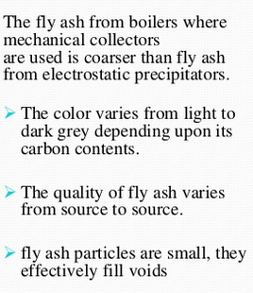 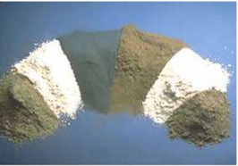

**Operations areas**

**(1) Wanakbori:-**

This Power Station is located near Wanakbori Dam on the bank of Mahi River in Kheda District of Gujarat. It is a Coal Based Power Station. There are seven units of 210 MW each with a total installed capacity of 1470 MW. The total quantity of classified fly ash is 200tpd ~6,000tpm**.**

**(2) Gandhinagar:-**

This Power Station is located pathapur near Sabarmati River in Gandhinagar District of Gujarat. It is a Coal Based Power Station. They have five Units. Out of five units, 3 unit produce 210MW and oyher two units produce 120MW each with a total installed capacity of 870 MW.